Conference Scientific Committee
BIOLOGY:
Aurel Ardelean
Gheorghe Emil Bandici
Cornelia Craciunas
Diana Cupsa
Gyorgy Devai
Carmen Gache
Iordache Ion
Amorin Popa
Cornelia Purcarea
Camelia Sand
Ilie Telcean
Constantin Toma
Nicolae Tomescu
CHEMISTRY:
Pasvanoglu Suzan
Burtică Georgeta
Zoltan Galbacs
Iovan Vasile
Danciu Ioan
Iovi Aurel
Bulgariu Dumitru
Badea Gabriela
Pica Maria Elena
Cimpoiu Claudia
Cărăban Alina
Fodor Alexandrina
Stănăşel Oana
Gavriş Georgeta
computer science:
Florian M. Boian
Mitica Craus
Ioan Despi
Dan Dumitrescu
Mircea Marin
Victor V. Patriciu
Constantin Popescu
Daniela Elena Popescu
Pantelimon Stanica
Athanassios D. Styliadis
Michael Gr. Vasssilakopoulos
MATHEMATICS:
Mircea Balaj
Adrian I. Ban
Barnabas Bede
Daniel Breaz
Graţiela Cicortaş
Lucian Coroianu
Sorin G. Gal
Physics:
Antohe Ştefan
Ardelean Ioan
Avram Nicolae
Chiş Vasile
Cosma Constantin
Cozar Onuc
Culea Eugen
David Leontin
Filip Sanda
Jurcuţ Teodor
Macocian Eugen-Victor
Moca Paşcu Cătălin
Neda Zoltan
Pop Aurel
Şimon Viorica
Local organizing committee

Rectorate of the University of Oradea
BUNGAU CONSTANTIN – Rector
SIPOŞ SORIN – Vice-rector
CURILă SORIN – President of the University’s Senate

Faculty of Sciences
Filip Sanda Monica – Dean
GAL SORIN – Vice-dean
OROS HOREA - Conference Secretary

Department of Biology
CUPŞA DIANA – Head of the Department
BLIDAR CRISTIAN
COVACIU-MARCOV SEVERUS DANIEL
PETRUŞ ADRIANA
SAS ISTVAN
Department of Chemistry
CĂRĂBAN ALINA – Head of the Department
BADEA GABRIELA
COZMA ALINA
FODOR ALEXANDRINA
GAVRIş GEORGETA
HODişAN SORIN
MORGOVAN CLAUDIA
SEBeşAN MIOARA
STĂNĂşEL OANA
Department of Mathematics and Informatics
POPESCU CONSTANTIN – Head of the Department
ALB LUPAş ALINA
BICA ALEXANDRU
CăTAş ADRIANA
erzse daniel
fechete dorina
fechete ioan
ion vasile
kos victor
LASLO EUGEN
MERCA DELIA
noje dan
OROS HOREA
Scurtu sorin
Department of Physics
Macocian Eugen-Victor– Head of the Department
BEIUŞEANU FLORIAN
CĂPITANU CARMEN
CHIONCEL LIVIU
FLORA MONICA
HOREA CRISTIAN
MOCA pAŞCU CĂTĂLIN
marcu loredana
SIMUŢ CECILIA
TODERAŞ MONICA

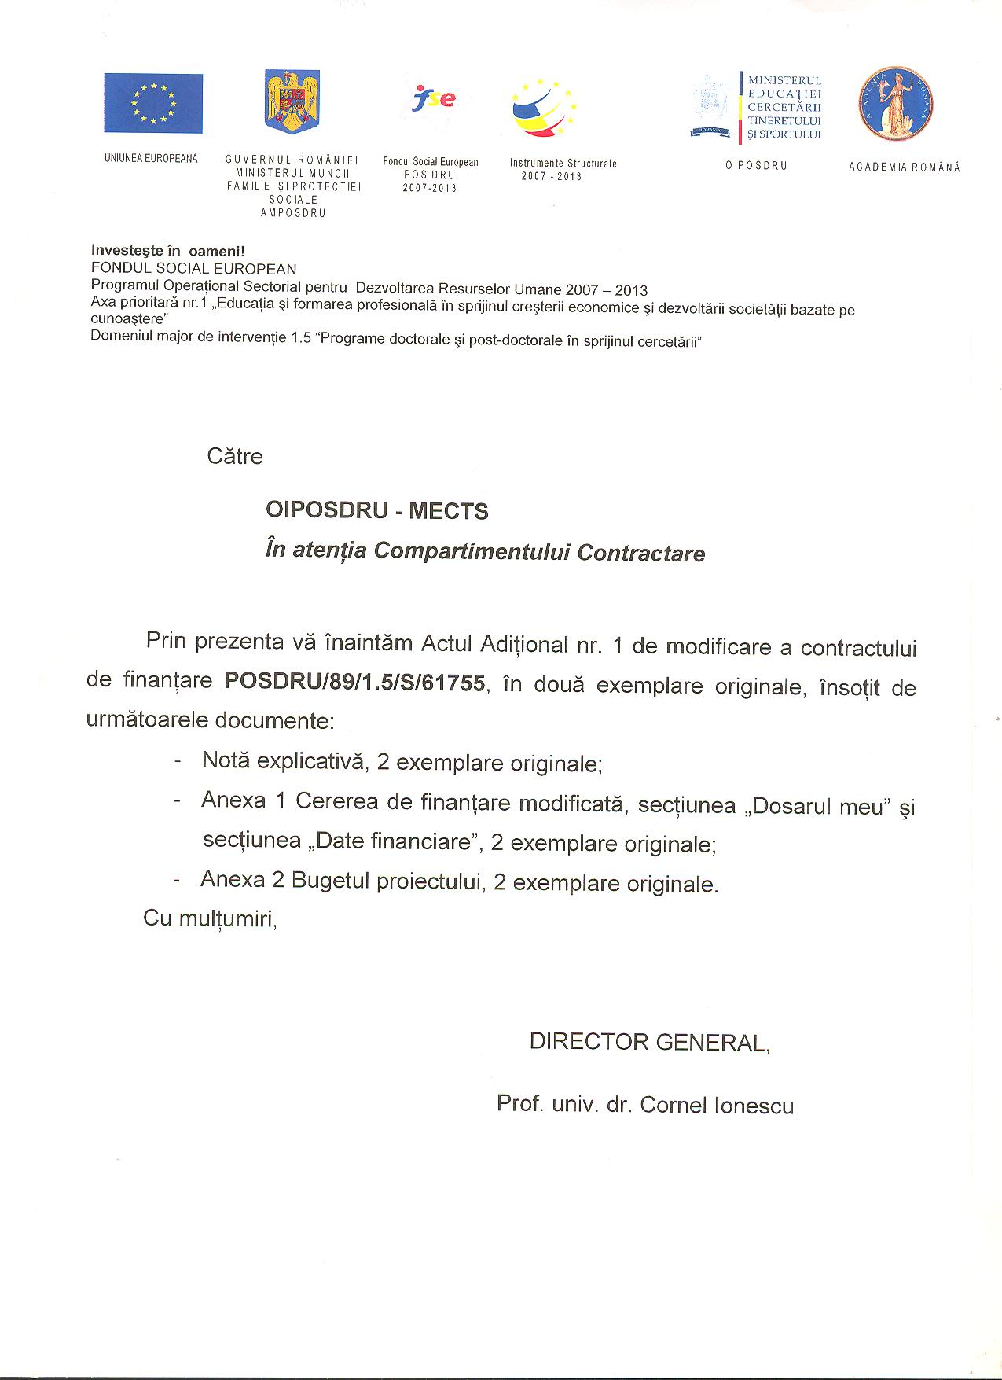

UNIVERSITY OF ORADEA
FACULTY OF SCIENCES
Universităţii Street no. 1
ORADEA 410087
ROMANIA
Tel: 00-40-259-408161

INTERNATIONAL CONFERENCE ON SCIENCES
UNIVERSITY OF ORADEA
FACULTY OF SCIENCES
8-9 NOVEMBER 2013
ORADEA

Preliminary registration form
Name _____________________________
First name__________________________
Title_______________________________
Institution___________________________
Address ____________________________
Phone______________________________
Fax _______________________________
e-mail______________________________

I would like to participate at the conference with a paper related to the following topics:
_____________________________________
_____________________________________
Author(s)_____________________________
_____________________________________
Title_________________________________
_____________________________________
Signature_____________________________
Date_________________________________

Send to: UNIVERSITY OF ORADEA
FACULTY OF SCIENCES
Universităţii Street no.1
ORADEA 410087
ROMANIA
Tel: 00-40-259-408161

Conference web site:
http://stiinte.uoradea.ro
Conference topics:
Biology
- Animal Biology
- Aquatic fauna
- Ecology
- Herpetology
- Paleontology
- Genetics
- Vegetal Biology
- Biotechnology
- Microbiology
- Botany
Chemistry
- Inorganic Chemistry
- Organic Chemistry
- Analytical Chemistry
- Physical Chemistry
- Material chemistry
- Environmental Chemistry
- Biochemistry
- Chemical technologies
- Computational Chemistry
- Food Chemistry
Computer Science
- Computer Science
- Internet Based Data Bases
- Software for Parallel and Distributed Systems
- Mobile and Wireless Computing
- Cryptography and Security
- Distributed Database
- Multimedia
Mathematics
- Algebra and Applications
- Numerical Analysis and Applications
- Differential Equations and Applications
- Mathematical Analysis
- Probabilities
- Statistics
- Algorithms
Physics
- Material science. Nanostructures. Superconductivity
- Biophysics
- Environmental Physics
- Theoretical and Computational Physics
Language: the official language of the conference is English
Accommodation : details on conference site :
http://facultatea-stiinte-oradea.ro/en/events
Publication: the accepted paper will be published in the Conference Proceedings (with ISSN) and in various scientific journals.
Contact person : Sorin Gal, e-mail : galso@uoradea.ro

Preliminary program

8th of November 2013
11.00 Registration
12.00 Opening ceremony (Aula Magna, University of Oradea)
13.30 Lunch (optional)
14.00 – 16.30 Plenary sessions
16.30 – 17.00 Coffee break
17.00 – 19.30 Parallel sessions
19.30- Welcome dinner

9th of November 2013
09.00 Parallel sessions
10.30 Coffee break
11.00 Parallel sessions
12.30 Lunch
15.00 Visit at the Felix Springs (optional)
19.00 Dinner (optional)

Contact persons:
Biology: PETRUŞ ADRIANA adrianavan@yahoo.com
Chemistry: Cozma alina acozma@uoradea.ro
Mathematics and Computer Science: ALB LUPAş ALINa
dalb@uoradea.ro
Physics: marcu loredana loredana@marcunet.com

Deadlines:
Full paper submission: 1st of October 2013
The instructions for the papers are found on the conference web site and at the contact person of each topic.

Notification for acceptance: 10th of October 2013
Participation registration: 25th of October 2013
Conference fee payment: 1st of November 2013
Conference fee: 100 lei , students: 25 lei (student quality attested by a warrant). Includes materials of the conference and coffee breaks.

Conference Location : Hotel Anthimos in “Felix Springs” (“Baile Felix”), at 10 km from Oradea (www.anthimos.ro)

