Conference Scientific Committee
BIOLOGY:
Aurel Ardelean
Gheorghe Emil Bandici
Klaus Werner Battes
Cornelia Craciunas
Diana Cupsa
Carmen Gache
Iordache Ion
Amorin Popa
Cornelia Purcarea
Camelia Sand
Ilie Telcean
Constantin Toma
Nicolae Tomescu
CHEMISTRY:
Pasvanoglu Suzan
Burtică Georgeta
Zoltan Galbacs
Iovan Vasile
Danciu Ioan
Iovi Aurel
Bulgariu Dumitru
Badea Gabriela
Pica Maria Elena
Cimpoiu Claudia
Cărăban Alina
Fodor Alexandrina
Stănăşel Oana
Gavriş Georgeta
computer science:
Florian M. Boian
Mitica Craus
Ioan Despi
Dan Dumitrescu
Mircea Marin
Victor V. Patriciu
Constantin Popescu
Daniela Elena Popescu
Pantelimon Stanica
Athanassios D. Styliadis
Michael Gr. Vasssilakopoulos
MATHEMATICS:
George Anastassiou
Mircea Balaj
Adrian I. Ban, Romania
Barnabas Bede
Alexandru M. Bica
Daniel Breaz
Grațiela Cicortaș
Sorin G. Gal
Daniel Pașca
Emil Schwab
Mihail Ursul
Physics:
Antohe Ştefan
Ardelean Ioan
Avram Nicolae
Chiş Vasile
Cosma Constantin
Cozar Onuc
Culea Eugen
David Leontin
Filip Sanda
Jurcuţ Teodor
Macocian Eugen-Victor
Moca Paşcu Cătălin
Neda Zoltan
Şimon Viorica
Local organizing committee

Rectorate of the University of Oradea
ANTAL CORNEL – Rector
Jurcuţ Teodor – Vice-rector
CURILă SORIN – Scientific Secretary of the University

Faculty of Sciences
Filip Sanda Monica – Dean
GAL SORIN – Vice-dean,
FODOR ALEXANDRINA – Scientific Secretary of the Faculty
PETRUŞ ADRIANA - Conference Secretary

Department of Biology
CUPŞA DIANA – Head of the Department
BLIDAR CRISTIAN
COVACIU-MARCOV SEVERUS DANIEL
SAS ISTVAN

Department of Chemistry
CĂRĂBAN ALINA – Head of the Department
GAVRIş GEORGETA
STăNăşEL OANA
HODişAN SORIN
SEBeşAN MIOARA

Department of Mathematics and Informatics
POPESCU CONSTANTIN – Head of the Department
ALB LUPAş ALINA
BICA ALEXANDRU
CăTAş ADRIANA
LASLO EUGEN
MERCA DELIA
Scurtu sorin
fechete ioan
fechete dorina
erzse daniel
popescu liviu
kos victor
ion vasile
noje dan
OROS HOREA

Department of Physics
Macocian Eugen-Victor– Head of the Department
BEIUŞEANU FLORIAN
CHIONCEL LIVIU
FLORA MONICA
HOREA CRISTIAN
MOCA pAŞCU CĂTĂLIN
SIMUŢ CECILIA
TODERAŞ MONICA

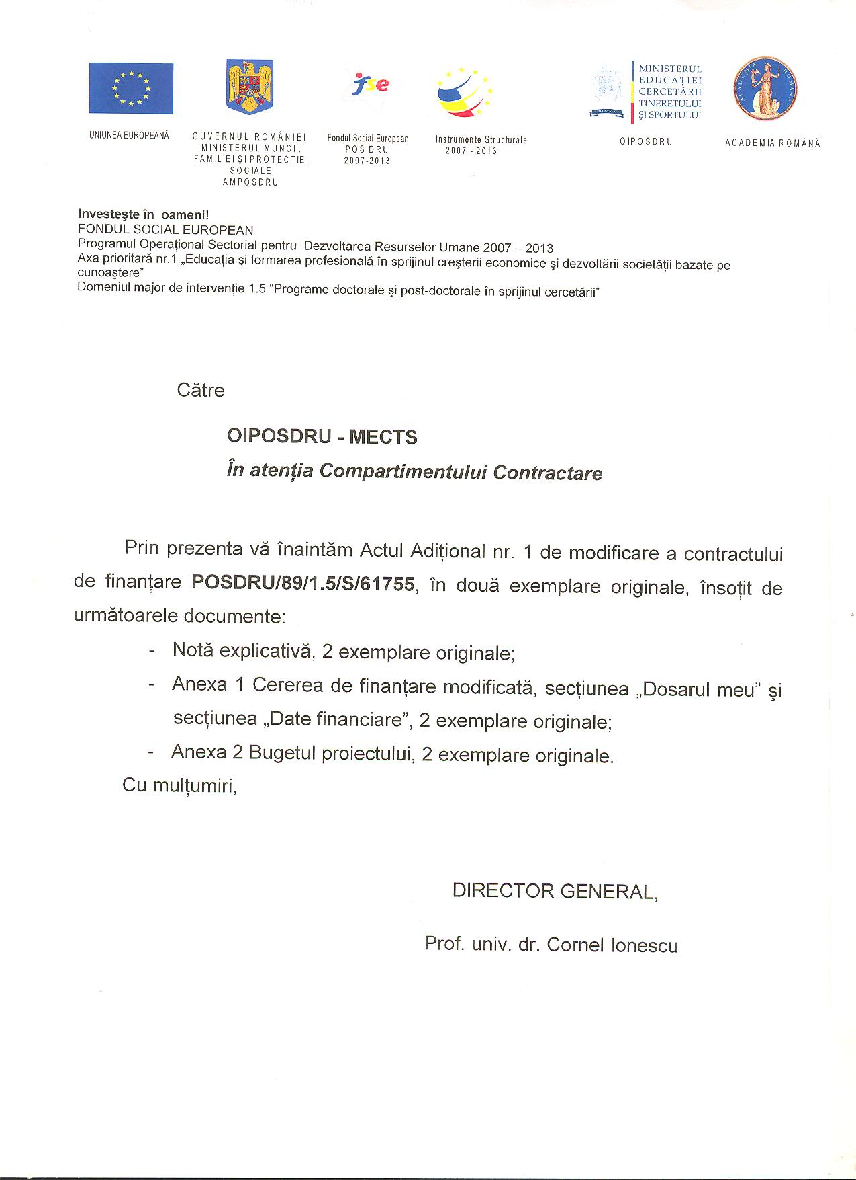

UNIVERSITY OF ORADEA
FACULTY OF SCIENCES
Universităţii Street no. 1
ORADEA 410087
ROMANIA
Tel: 00-40-259-408161

INTERNATIONAL CONFERENCE ON SCIENCES
UNIVERSITY OF ORADEA
FACULTY OF SCIENCES
11-12 NOVEMBER 2011
ORADEA

Preliminary registration form
Name _____________________________
First name__________________________
Title_______________________________
Institution___________________________
Address ____________________________
Phone______________________________
Fax _______________________________
e-mail______________________________

I would like to participate at the conference with a paper related to the following topics:
_____________________________________
_____________________________________
Author(s)_____________________________
_____________________________________
Title_________________________________
_____________________________________
Signature_____________________________
Date_________________________________

Send to: UNIVERSITY OF ORADEA
FACULTY OF SCIENCES
Universităţii Street no.1
ORADEA 410087
ROMANIA
Tel: 00-40-259-408161

Conference web site:
http://stiinte.uoradea.ro/conf2011/internationala/ICS2011.html
Conference topics:

Biology
- Animal Biology
- Aquatic fauna
- Ecology
- Herpetology
- Paleontology
- Genetics
- Vegetal Biology
- Biotechnology
- Microbiology
- Botanies
Chemistry
- Inorganic Chemistry
- Organic Chemistry
- Analytical Chemistry
- Physical Chemistry
- Material chemistry
- Environmental Chemistry
- Biochemistry
- Chemical technologies
- Computational Chemistry
- Food Chemistry
Computer science
- Computer Science
- Internet Based Data Bases
- Software for Parallel and Distributed Systems
- Mobile and Wireless Computing
- Cryptography and Security
- Distributed Database
- Multimedia
Mathematics
- Algebra and Applications
- Numerical Analysis and Applications
- Differential Equations and Applications
- Mathematical Analysis
- Probabilities
- Statistics
- Algorithms
Physics
- Material science. Nanostructures. Superconductivity
- Biophysics
- Environmental Physics
- Theoretical and Computational Physics

Language: the official language of the conference is English
Accommodation: details on the conference site:
http://stiinte.uoradea.ro/conf2011/internationala/ICS2011.html
Publication: the accepted paper will be published in the Conference Proceedings and in various scientific journals.
Preliminary program

11th of November 2011
11.00 Registration
12.00 Opening ceremony (Aula Magna, University of Oradea)
13.00 Transfer to Conference Location-Hotel Ramada, Oradea
13.30 Lunch (optional)
14.00 – 16.30 Plenary sessions
16.30 – 17.00 Coffee break
17.00 – 19.30 Parallel sessions
19.30- Welcome dinner

12th of November 2011
09.00 Parallel sessions
10.30 Coffee break
11.00 Parallel sessions
12.30 Lunch
15.00 Visit at the Bear’s Cave
19.00 Dinner (optional)

Contact persons:
Animal Biology: ISTVAN SAS isas@uoradea.ro
Vegetal Biology: BLIDAR CRISTIAN cblidar@uoradea.ro
Chemistry: CARABAN ALINA acaraban@uoradea.ro
Mathematics and Computer science: OROS HOREA, horos@uoradea.ro
Physics: Horea Cristian, chorea@uoradea.ro

Deadlines:
Full paper submission: 1st of October 2011
The instructions for the papers are found on the conference web site and at the contact person of each topic

Notification for acceptance: 10th of October 2011
Participation registration: 25th of October 2011
Conference fee payment: 1st of November 2011
Conference fee: 150 lei
Students: 25 lei (student quality attested by a warrant)

The Conference is cofinanced from the European Social Fund, through Sectorial Operational Programme Human Resources Development 2007-2013, project number POSDRU/CPP 107/DMI 1.5/S/77082/2010

Conference Location-Hotel Ramada, Oradea

